Development and Techniques of
Film and Video Editing

Lo1.1 Critically Review the Development of Editing Technology
Lo1.2 Critically Review the Development of Editing Practice

Throughout the first part of this essay I will be looking at five Pioneers of cinema and how they helped shape the development of editing techniques.

Georges Méliès
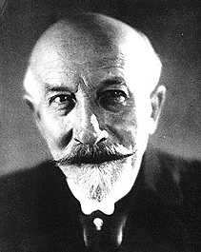
Born in Paris 1861, Méliès was an audience member when the Lumiere Brother’s revealed their Cinematography to the public, this sparked Méliès interest in moving image, he approached the Lumiere brothers after the show with the idea of buying their machine – they turned him down.

Méliès went on to investigate moving image more and built his own camera. When filming one day his camera jammed, causing an odd effect within the film. This incident lead to his discovery and development of “the first double exposure (La caverne Maudite, 1898), the first split screen with performers acting opposite themselves (Un Homme de tete, 1898), and the first dissolve (Cendrillon, 1899)” (Walters, J. 2002).

The Dissolve - Georges Méliès developed this editing technique; it is a gradual transition from one image to another. “Stopping the camera, rolling the film back, and exposing the next shot were used to create this effect” (Columbia University. 2015). This technique comes under the editing practice of in camera editing.

Sergei M. Eisenstein
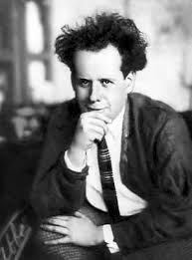
Born in Latvia in the late 19th Century. Eisenstein made his first feature film “Strike” in 1925.

“Eisenstein’s defining accomplishment was his role as a critical film theorist. His pioneering of stylistic techniques and editing methods came to define modern cinema. Eisenstein’s montage theory reevaluated the way in which films were being edited and transformed: from the actual filming, to the editing process, and finally the projection” (Samuels, A.J. 2016).

Montage Editing – Used by Eisenstein montage editing is a technique that involves a juxtaposition of shots in a fast-paced fashion, this helps to convey information in a short period, within a film. Eisenstein famously argued, “each sequential element should be perceived not next to the other, but on top of the other” (Samuels, A.J. 2016). When this technique was developed it was executed using the cut and splice editing technique.

Robert Wiene
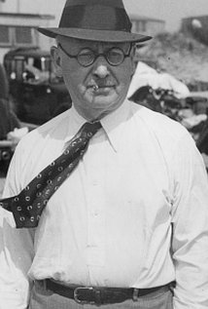
Born in 1873 in Silesia, Germany. Wiene is best known for his film “The Cabinet of Dr. Caligari, 1920” (Anon. 2014).

When Directing The Cabinet of Dr. Caligari, Wiene used “very little camera movement and editing within scenes” (Anon. 2015). The only editing techniques that are evident throughout Wiene’s films are dissolves and cut and splice editing.

Cut and Splice Editing – This editing technique was the first form of film editing and forms the basis of all other modern day video editing platforms. This technique was executed by cutting sections of the film and rearranging or discarding them. A splicing machine was then used to hold the film in place so both pieces could be joined together (MediaCollege. 2016).

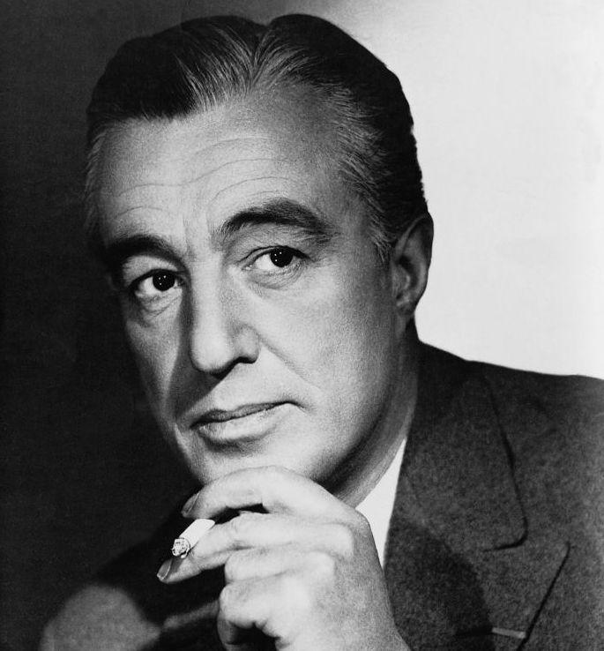
Vittorio De Sica
Born in 1902 in Sora, Italy. De Sica was a film Director and Actor during the Italian Neorealist movement (Encyclopedia Britannica. 2008).

Best known for his film “The Bicycle Thieves” De Sica “employed a well developed mise-en-scene to achieve objective reality” (Mooney, J. 2013). De Sica famously used continuity editing techniques for a more realist feel within his films. De Sica is also known for combining sound with his films.

Continuity Editing – This is a style of editing that requires the Director and Editor to work together to make the film’s reality as close to the audience’s reality as possible (Anon. 2010).

Francis Ford Coppola
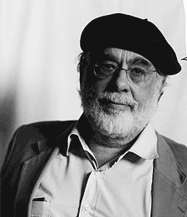
Born in 1935 in Detroit, Michigan. Internationally famous for his film “The Godfather, 1972” (Biography.com Editors. 2014).

Coppola is known for using an editing technique known as intercutting within his films (Maher, M. 2015). Coppola as been known to enjoy the classic style of editing through the cut and splice technique, as well as moving into the digital age and using Final Cut Pro. During the making of “Bram Stoker’s Dracula, 1992” Coppola became the first Director of a major film to utilize a nonlinear editing machine (Anon. 2013).

Intercutting – This term is used to describe an editing technique that is used to cut back and forth from between separate locations within one scene (Maher, M. 2015).

Nonlinear Editing – This term refers to an editing technique/system that allows you instant access to any scene you wish to edit and any time. This allows you to work on any segment of your film at any time. In nonlinear editing your original source files are not lost, this is done through an editing decision list that is used to record the decision of the editor (Motion Elements. 2013).

Conclusion – As we can see from the first part of this essay, each of these Directors’ had their own techniques and styles of editing their films. We can see which Director’s helped to develop new editing techniques and those who deserve to be named a pioneer of early cinema. We can also see how some of the older editing techniques can be applied in the digital age.

Lo1.3 Analyse Genre Specific Editing Technique

Throughout the second part of this essay I will be delving into genre specific editing techniques, to do this I will be looking at two fictional films and two TV dramas. I will analyse the different editing styles from each case study and compare to those from my chosen pioneers from the first part of this essay. The genre that I have chosen to look at for this part of the essay is Horror.
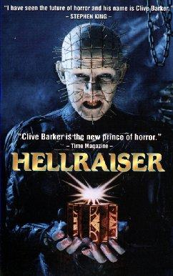
Hellraiser 1987
The first film I have chosen to look at is Clive Barker’s Hellraiser (1987). The reason I have chosen this film is I feel that it was the first of its kind. Hellraiser explores the dark and twisted nature of humanity. This film also uses lighting, effects and editing techniques to the best of its ability and for its time.
Editing Techniques – Throughout the Hellraiser film the editing techniques used are minimal and quite simplistic. A lot of straight cuts have been used throughout scenes, as well as cuts to black and montage editing. This is evident from the scenes “We’ll Tear Your Soul Apart” (Shudder. 2015) and “It Opens Doors” (Shudder. 2015).

Lighting – The lighting technique combined with the editing techniques were used to capture the imagination and fear of the films audience. Throughout Hellraiser low-key lighting is used, this is to help create a claustrophobic/horror atmosphere, combined with the straight cuts and montage editing both aspects give the film its overall cult horror film feel and status.

Sound – “Except when we are informed in a few special cases, the sound design gives us no clues as to where we are located in the reality/dreamworld. The dreamworlds are sonically presented to us as just alternative reality” (Collins, K. p198. 2009). This means that no sound effects have been used to inform us the viewer when reality becomes a dreamworld; no reverb or other effects have been added to the sound, thus adding to the audience’s paranoia, confusion and terror throughout the film.

Camera – during the research process of this essay I was unable to find any information on the cameras used for production.

Pace – The pace throughout the Hellraiser film is quite steady, at the beginning of the film we are shown the “Lament Configuration (Puzzle Box) and the consequences of opening the box, a few minutes later we are shown the main Antagonists Pinhead and the other Cenobites. This tells us that Hellraiser has a steady yet somewhat quickened pace, by showing us the villains at the beginning rather than half way through the film. The rest of the film follows the resurrection of the first victim within the opening scene and his seduction of another main character and her stepdaughter’s fight to rid the world of Pinhead. With a run time of 1 hour 30 minutes, the pace, editing and music together holds the audiences attention throughout the entire film (Hellraiser. 1987).

Effects – Throughout the Hellraiser film we can see many different special effects, such as: make-up, props and various animated effects. The cenobites within the film were created by using various special effects make-up techniques. “I suggested that maybe they should be like thin pins, and because of this series of conversations, through trial and error we ended up with that design of Pinhead, which has become so iconic over time”, “Butterball came out of the fact that we were just talking about an idea of this really fat character and how he'd play with his wounds all the time. Chatterer came out of what we were calling at the time ‘the poor bastard,’ because we decided to design a mask where poor Nick (Vince) couldn't see anything at all. Nick had this ability to make his teeth chatter. It was almost weird, it was like it was freezing cold and he could chatter his teeth, so that became part of that character. The female Cenobite came out of a direct drawing from Clive.” (Wixson, H. 2017).

Other effects within this film were things such as lighting strikes when the cenobites and pinhead would appear, these were created by drawing onto the film and creating flashes within the film itself due to running out of budget. Other effects that we see within the Hellraiser film are the Puzzle Box and small human organs, “Designing the [puzzle] box and the mechanics of the box, I worked with Simon Sayce, who was working for me on that. We had about four people who would then work out the problems of the box. We came up with the little beating heart thing that's under the floor almost on the day we ended up shooting it. It was made out of a condom, a piece of tubing, some glue, and some bits and pieces to pull the whole thing together and make it look like a real human organ.” (Wixson, H. 2017)

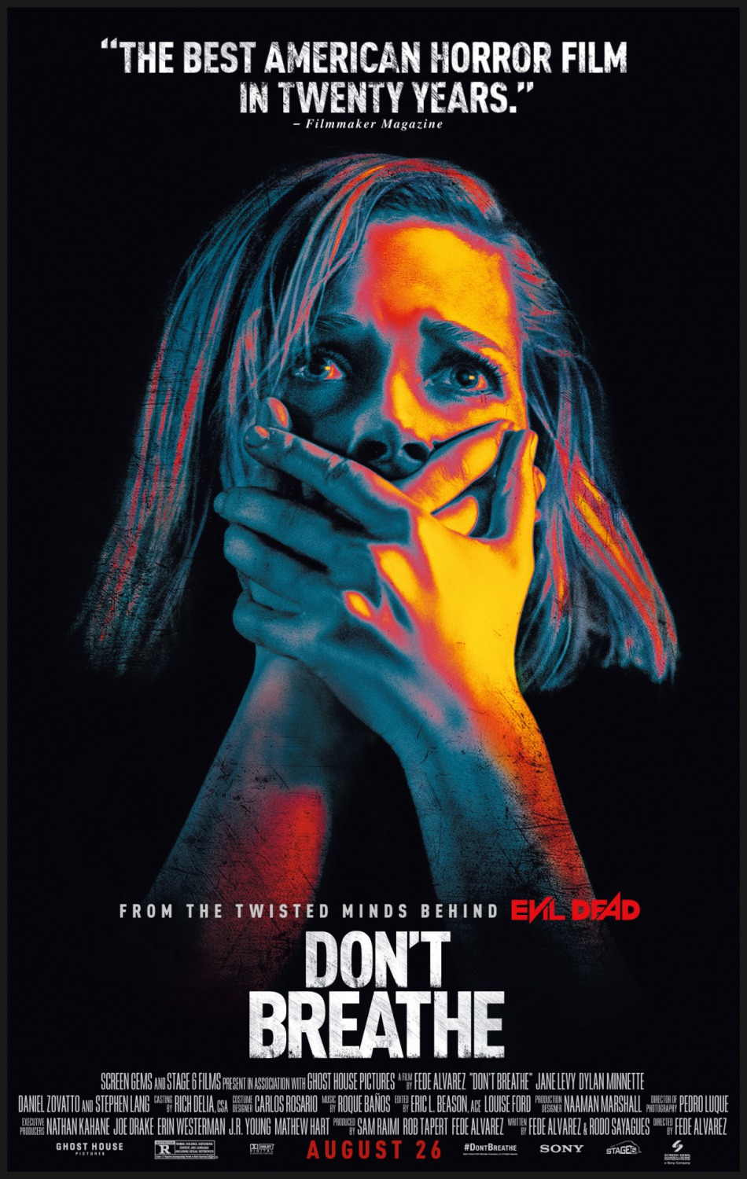
Don’t Breathe 2016
The second film I have chosen to look at is Fede Alvarez’s Don’t Breathe. The reason I have chosen to look at Don’t Breathe is I feel that it was the first film of it’s kind, to follow and address some of the themes that it did and the best horror film to have been made within the last 20-25 years. This film also uses editing techniques and lighting to the best of its ability.

Editing Techniques – Throughout the film we can see that Alvarez utilizes impressive editing techniques, from the use of fake-cuts, to seemingly long one shots.
“There’s a long take early in the movie where they enter the house for the first time – you see a lot of elements and spaces that are going to be important later in the story in one shot. It looks like one single shot that goes through the whole house, but it was a combination of old techniques. When the camera needed to go under the bed, we hid a cut as it went close to the drapes, and once it goes under the bed the bed is actually up very high but you don’t know it because you don’t see the floor – you’re looking at the underside of the bed.” (Hemphill, J. 2016).

Lighting – Throughout the film we can see an immersive use of natural light, low-key lighting and often the movie was filmed in the dark using a night vision camera, the lighting within this film was used to the best of its ability and created a claustrophobic and terrifying atmosphere for the viewer (Don’t Breathe. 2016).

“We also had a sequence in total darkness that we didn’t want to shoot with a character having night vision goggles, like in Silence of the Lambs, or a video camera with night vision like characters usually have in that kind of scene. The idea was to establish darkness for the characters where the audience could still make out what was happening, and I’m hoping that’s a little step forward in terms of film language.” (Hemphill, J. 2016).

Sound – When watching Don’t Breathe we can see that the movie relies mainly on sound effects rather than dialogue to create the terror throughout the film (Don’t Breathe. 2016). “The film has a small amount of dialogue between characters, but this also adds to the suspense. The antagonist doesn’t actually speak more than a few words with the exception of one scene in the film, leaving each and every moviegoer in a dead silence; Alvarez truly seems to recognize the power of the cliché “silence is golden”.” (Parr, S. 2016).

“To score the horror movie, Don’t Breathe, opening Aug. 26, the Spanish composer turned to instruments made out of household appliances and items collected from cars, grills, farming equipment and other gadgets, many of them salvaged from junk yards. The idea was to create a musical level of dread from seemingly innocent, inanimate objects. “Anything you could find in a house that could make a noise, that noise makes music," Banos says. “The house, in a way, becomes alive, saying, ‘You are not going to escape from here.’” (Newman, M. 2016).

Camera – From the website Shotonwhat.com we can see the camera’s that were used on this production were, “ARRI ALEXA XT Camera, Black Magic Pocket Cinema Camera, Phantom Flex4K Camera and Red Epic Dragon Camera.” (Anon. 2016).

Pace – The beginning of Don’t Breathe flows at a steady pace, with the home invaders breaking into a blind veteran’s home, until he realizes people are in his house, the steady pace combined with the suspense aspects created by editing and sound design help hold the audiences’ attention until the final 30 minutes of the film (Don’t Breathe. 2016). However “The last 30 minutes of Don't Breathe are straight-up bonkers. The film moves at such a frenzied pace that it flies right off the tracks into a shocking and satisfying finale that is gleefully depraved.” (Frazier, A. 2016).

Effects – When watching Don’t Breathe we can see that the director decided to go with minimal usage of special effects, however this being said, the film shows a gory death scene in which one of the intruders is shot and rather than panning away from the death Alvarez decided to show it on screen, using a variety of special effects combined with impressive acting skills. Other special effects within the film are mainly blood splatter and gore, making Don’t Breathe a unique attribute to the horror genre that usually relies heavily on special effects to create the desired terror and claustrophobic atmosphere that all horror fans have grown to know and love (Don’t Breathe. 2016).

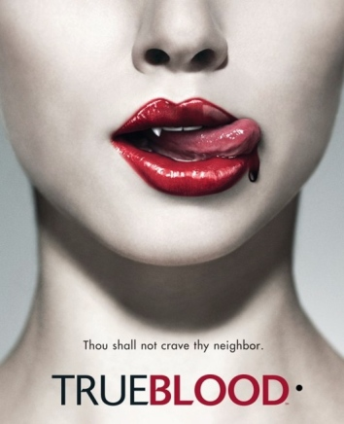
True Blood 2008 - 2014
The first TV drama I have chosen to look at is True Blood. The reason I have chose to look at this show is because it fits into the genre that I am most found of and I feel that it uses editing, lighting and special effects, that no other TV show has.

Editing Techniques – Based upon my own observations True Blood is a prime example of a multi camera production, with straight cuts between various shots and camera angles, True Blood goes back to the basic and simpler still of editing, even down to the fact film was used up until season 4 of the show (True Blood. 2008-2014). This is evident from the scene “Eric – Godric Last Scene, Godric Dies” (Bill X. 2010). From looking at ShotonWhat.com we can see that the editing software used was Avid Editing Software (Anon. 2016).
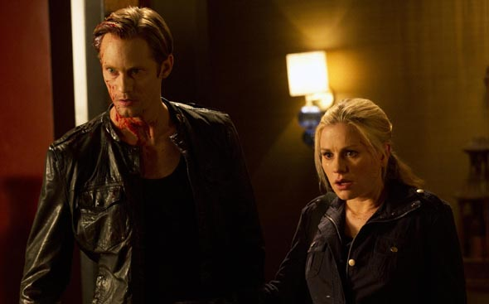
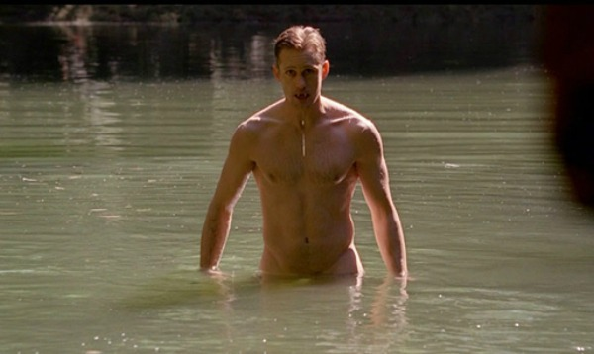
Lighting - From my own observations and from looking at the images above we can see that most of the lighting used within the show was low key Tungsten lighting, where as all outdoor scenes were shot in natural lighting (True Blood. 2008-2014).

Sound – The sound within True Blood was shot to be used with Dolby Digital systems, for this reason the sound is crisp and clear throughout each episode (True Blood. 2008-2014).

“The score features a full-bodied sound, the dynamic range is impressive, and the creative sound design utilizes every speaker in the room. Quiet passages reveal crickets chirping, and dialog is never strained.” (Vaughn, D. 2009).

From my observations of the show it is clear that various sound effects and distortions have been used throughout scenes. For example: by watching the opening scene from season 1 episode 1, we can hear music playing loud within the truck, then it switches to sounding as if it were coming from the truck’s stereo as the dialogue begins (True Blood. 2008-2014).

Camera – From the website ShotonWhat.com we can see that cameras used during the filming of True Blood were: ARRICAM Lite (LT) Camera, ARRICAM Studio (ST) Camera and Moviecam Compact Camera (Anon. 2016).

“When I started we were editing SD and capturing from DVCAM offline. We went tapeless and HD Season 4. For the final season the big difference was we stopped shooting film and went digital (using the Arri Alexa). We are using DNxHD 36 for post workflow.” (Altman, R. 2014)

Pace – The pace within each season of True Blood differs. Within the first season the pace is pretty slow yet steady with Sookie meeting Bill the vampire for the first time in episode one and being enthralled with him by mid season. The pace is backed up by the stripped back editing still of straight cuts, however the viewers attention is held by the nature of the storyline, the character development and the effects the soundtrack have when pared with the action within the show (True Blood. 2008-2014).

Effects – True Blood uses an abundance of effects throughout each season; we are guaranteed to see blood shed, fangs, vampire speed, etc. within each episode, all of the special effects used within the TV series was created by one company ZOIC Studios. “ZOIC Studios was along for the ride from the dawn. From gushing facial wounds, flying decapitated heads, massive explosions, fiery slow motion attacks, gruesome disintegrating bodies, and of course—an infinite bounty of blood in every fashion imaginable. Coming on board for the pilot and continuing through the series’ finale in 2014” (ZOIC. 2017).
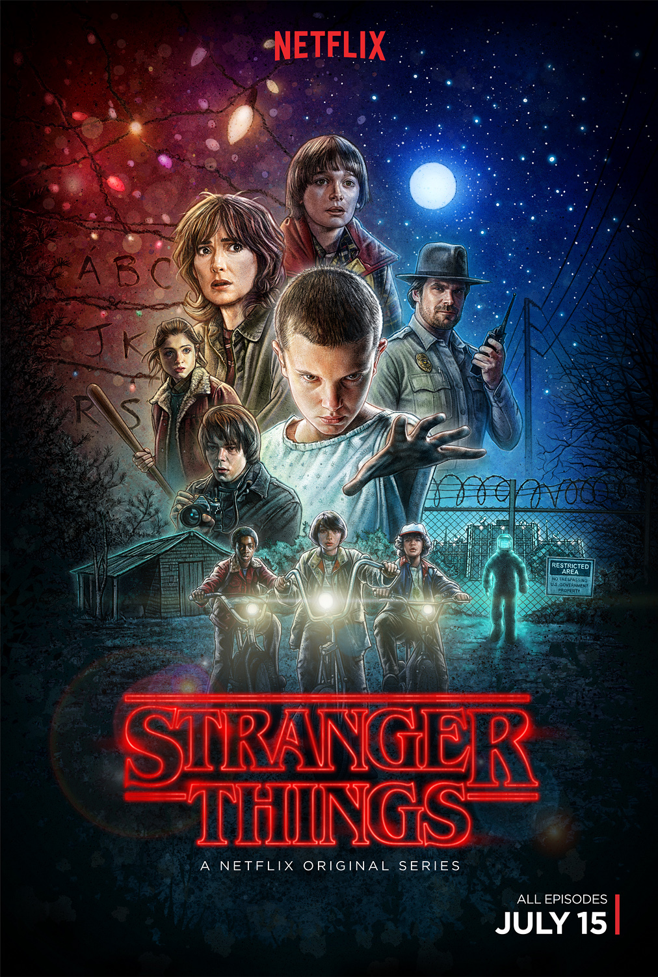
Stranger Things (2016)
The second TV show I have chosen to look at is the Netflix original series Stranger Things. The reason I have chosen to look at this series is because I feel that it is an ode to classic cinema and film making, within the horror/sci-fi genre.

Editing Techniques – Despite kicking it old school and taking the back to the 80s’, Stranger Things uses some of the most innovative editing techniques, these techniques differ from the classic fades, straight cuts and dissolves. Stranger Things uses 2 of the most unique cuts within editing, the Contrast Cut and Graphic Match.
Contrast Cut – “Working off of the power of juxtaposition, contrast cuts transition from one extreme to another, hitting the viewer emotionally and physiologically in an unexpected way. And the more popular these types of transitions become, the more edgy they become. Stranger Things utilizes this type of cut during Eleven's flashbacks” (Renee, V. 2016).

Graphic Match – “This transition is simple and straightforward, but can be both stylish and effective. A graphic match occurs when two shots are cut together that contain similar shapes in similar positions within the frame. Stranger Things has used this transition many times in the show, like when Eleven is walking through the store and has a flashback of being brought into the lab” (Renee, V. 2016)

Lighting – When watching Stranger Things we can see that a lot of the lighting used was Tungsten lights, indoor household lights and a lot of low-key lighting (Stranger Things. 2016).

““I had initially intended to shoot the school day exteriors seen early in the series in backlight, but it didn’t fit our schedule,” Ives continues. “In reconsidering the ’80s look and feel, I referenced photographers William Eggleston and Saul Leiter, and we all agreed it would be more than okay to shoot frontlight instead. This gives the scenes a nostalgic, warmer look.”” (Martin, K, H. 2016).

“The plentiful night exteriors, during which all manner of chills and horrors manifest, merited lengthier discussions between Ives and the brothers. “Still photographer Gregory Crewdson [Beneath the Roses, Twilight] shoots a lot of night work that inspired me with its heightened reality. Alien, Close Encounters of the Third Kind and E.T. all have atmosphere to their night scenes, and for a lot of the early stuff—especially with the kids on their bikes—I used a lot of atmosphere, plus one big light for moonlight. Later, when we’re deep in the woods, the light was often a lot lower, keeping things looking a little edgy and scary.”” (Martin, K, H. 2016).

Sound – From my own observations the sound design for Stranger Things was great, from the sound track to the of the Christmas lights turning on and even the sound the Demogorgan made (Stranger Things, 2016).

“For most of the electrical sounds, I recorded little electric things around my house, and things I had in my garage. I don’t ever throw out old electric things that make noise. I keep bins of old toothbrushes, shavers, phones, etc. The one main thing I used was my battery charger, which has a 50 amp setting on it. I recorded that and then took little pieces, to which I added light bulb filament sounds. I broke some light bulbs and Christmas lights and I recorded the sound that the filament makes when you shake it a little bit. Of course, these are such low-level sounds – so I had to crank the heck out of them just to get them at a volume that I could use.” (Andersen A, 2016).

Camera – “We shot on the RED Dragon [camera] and we then added film grain that was scanned from 80s film stock on top, which is cool” ~ Matt Duffer (Thrower, E. 2016).

Pace – With only being 8 episodes long Stranger Things has one of the most interesting storylines that helps the pace of the show immensely, with each episode providing a new obstacle to over come (Stranger Things. 2016).

“The realisation of the horrific and the alien is always stark, and as emotionally arresting as it is visually troubling. And the show’s tone and pacing – both relentless, yet carefully considered – ensure that not a scene is wasted. Stranger Things is relatively lean at eight, 50-minute episodes, but it’s also one of the most dense and purposeful shows Netflix has produced to date. It’s a series of ceaseless momentum, in which every episode builds and drives the whole, be that by way of plot development, character growth, thematic exploration, or more often than not, all three in tandem. As a season, it plays out as a perfectly-tuned three-act movie, spread out over four times the usual running time, but never stretched or padded.” (Houghton, D. 2016).

Effects – It is evident when watching Stranger Things that the series is chalk full of special effects, from the Demogorgan to Eleven’s telepathic powers. The effects throughout the show are a solid mixture of both practical and digital effects, this gives the show more of an 80s/modern feel. (Stranger Things. 2016).

Mark Steger helped bring the Demogorgon to life by being the man standing on stilts inside of a creature suit, which also featured a mechanical head. “It was the most complex creature suit I’ve ever worked in. Being inside the suit changes your biometrics, how you see, how you hear. You have limbs in places you normally don’t. My vision was somewhat compromised, and my hearing was obscured by a motor in the headpiece. ~ Mark Steger”. Mark Steger didn’t always play the Demogorgon since there were instances when visual effects needed to be employed because of the limited movement of the practical body suit and headgear, but it’s great to see that they took the time to make a practical effect in order to stay true to the 1980s spirit of the show. (Anderton, E. 2017).

Conclusion – Throughout this essay I have learned that a lot of the older editing techniques and stills have been rethought out and applied to the digital edge of editing, however some filmmakers still like to work with the more classic style of editing, cut and splice editing and working with film. I have also learned that within the horror genre there seems to be a set of rules that every horror filmmaker must follow, however the two films and two TV shows I used as case studies, seem to break the mold of horror entirely and each Director brings something new and unique to their films.

Bibliography
Altman, R. (2014). #PostChat: ‘True Blood’ editor Mark Hartzell. America. postPerspective. Available at: postperspective.com/postchat-true-blood-editor-mark-hartzell [16/03/17]
Andersen, A. (2016). How The Outstanding Sound for ‘Stranger Things’ is Made. America. A Sound Effect. Available at: https://www.asoundeffect.com/stranger-things-sound/ [17/03/17]
Anderton, E. (2017). See How ‘Stranger Things’ Brought the Haunting Demogorgan to Life. America. Slash Film. Available at: http://www.slashfilm.com/stranger-things-monster-effects/ [17/03/17]
Anon. (2010). Continuity Editing. Unknown. Westminster, PBWorks. Available at: film110.com/w/page/12610182/Continuity Editing [08/03/17]
Anon. (2013). Francis Ford Coppola: Bram Stoker’s Dracula (1992). Unknown. The Director’s Series. Available at: directorsseries.tumblr.com/post/51167995611/francis-ford-coppola-bram-stokers-dracula-1992 [08/03/17]
Anon. (2014). Robert Wiene Biography. America. IMDb. Available at: http://www.imdb.com/name/nm0927468/bio?ref_=nm_ov_bio_sm [06/03/17]
Anon. (2015). The Cabinet of Dr. Caligari. America. Filmphest. Available at: filmphest.com/Films/caligari.htm [07/03/17]
Anon. (2016). Don’t Breathe (2016) Technical Specifications. America. Shot On What. Available at: https://shotonwhat.com/dont-breathe-2016 [15/03/17]
Anon. (2016). True Blood (2014) Technical Specs. America. Shot on What. Available at: https://shotonwhat.com/true-blood-2014 [16/03/17]
Bill X. (2010). True Blood Eric – Godric Last Scene Godric dies. Unknown. YouTube. Available at: https://www.youtube.com/watch?v=N9iljiuGxEOg [16/03/17]
Biography.com Editors. (2014). Francis Ford Coppola Biography. America. A&E Television Networks. Available at: http://www.biography.com/people/francis-ford-coppola-9257168 [08/03/17]
Columbia University. (2015). Dissolve. New York. The Columbia Film Language Glossary. Available at: https://filmglossary.ccnmtl.columbia.edu/term/dissolve/ [06/03/17]
Collins, K. (2009). Darkness and Discord. [e-book]. University of Waterloo. Available through: Research Gate, https://www.researchgate.net/publication/262424517_Like_Razors_through_Flesh_The_Sonic_Aesthetics_of_Hell_in_the_Hellraiser_Films [09/03/17]
Don’t Breathe. (2016). [film] Hungary/America: Fede Alvarez [15/03/17]
Encyclopedia Britannica. (2008). Vittorio De Sica, Italian Director. Unknown. Encyclopedia Britannica, Inc. Available at: https://www.britannica.com/biography/Vittorio-De-Sica [07/03/17]
Frazier, A. (2016). Review: Alvarez’s ‘Don’t Breathe’ is Effective & Engrossing Exploitation. America. FirstShowing.net. Available at: http://www.firstshowing.net/2016/review-fede-alvarez-dont-breathe-is-effective-and-engrossing-exploitation/ [15/03/17]
Hellraiser. (1987). [film] UK: Clive Barker. [15/03/17]
Maher, M. (2015). 4 Iconic Editing Techniques. Canada. Premiumbeat. Available at: https://www.premiumbeat.com/blog/4-iconic-editing-techniques/ [08/03/17]
Hemphill, J. (2016). “We Laid Out the Chessboard of the Movie”: Fede Alvarez on Don’t Breathe. America. Filmmaker Magazine. Available at: fimmakermagazine.com/99152-we-laid-out-the-chessboard-of-the-movie-fede-alvarez-dont-breathe - .WMmEx3el2Rt [15/03/16]
Houghton, D. (2016). Stranger Things Review: “One of the Best TV Chartacter-Pieces in Years”. America. Games Radar. Available at: http://www.gamesradar.com/stranger-things-review/ [17/03/17]
Martin, K, H. (2016). Netherworld – Stranger Things on Netflix. America. HD Video Pro. Available at: http://www.hdvideopro.com/film-and-tv/tv/stranger-things-netflix/ [17/03/17]
MediaCollege. (2016). Different Types of Video Editing. New Zealand. Media College. Available at: http://www.mediacollege.com/video/editing/tutorial/methods.html [07/03/17]
Mooney, J. (2013). The Bicycle Thieves and Italian Neorealism. Unknown. Filmosophy. Available at: https://filmandphilosophy.com/2013/03/08/the-bicycle-thieves-and-italian-neorealism/ [08/03/17]
Motion Elements. (2013). Understanding Linear vs Nonlinear Editing. Unknown. Motion Elements, Inc. Available at: https://www.motionelements.com/blog/articles/understanding-linear-vs-non-linear-editing [08/03/17]
Newman, M. (2016). ‘Don’t Breathe’ Composer on Turning Household Appliances Into Scary Instruments. America. Billboard. Available at: http://www.billboard.com/articles/news/7487845/horror-movie-dont-breathe-composer-roque-banos-household-appliances-scary-instruments [15/03/17]
Parr, S. (2016). Don’t Breathe refuses to rely on popular horror film techniques. America. Brock Press. Available at: http://www.brockpress.com/2016/09/dont-breathe-refuses-to-rely-on-popular-horror-film-techniques/ [15/03/17]
Renee, V. (2016). Watch: These Are 34 of the Most Creative Cuts in ‘Stranger Things’. America. No Film School. Available at: nofilmschool.com/2016/09/watch-34-most-creative-cuts-in-stranger-things [16/03/17]
Samuels, A.J. (2016). The Story of the Great Soviet Director Sergei M. Eisenstein. Unknown. Culture Trip. Available at: https://theculturetrip.com/europe/russia/articles/sergei-esenstein-s-montage-revolution/ [06/03/17]
Shudder. (2015). Hellraiser (1987) – It Opens Doors. Unknown. YouTube. Available at: https://www.youtube.com/watch?v=me2PIhsadd8 [09/03/17]
Shudder. (2015). Hellraiser (1987) – We Have Such Sights To Show You. Unknown. YouTube. Available at: https://www.youutbe.com/watch?v=Ns4EQlidg9w&t=1s [09/03/17]
Shudder. (2015). Hellraiser (1987) – We’ll Tear Your Soul Apart! Unknown. YouTube. Available at: https://www.youtube.com/watch?v=nfE74155WDI [09/03/17]
Stranger Things. (2016). [TV Show] America: Duffer Brothers [17/03/17]
Thrower, E. (2016). Stranger Things: the Duffer brothers share the secrets of their hit show. America. Empire Magazine. Available at: http://www.empireonline.com/movies/features/stranger-things-duffer-brothers-share-secrets-hit-show/ [17/03/17]
True Blood. (2008-2014). [TV Show] America: Alan Ball [16/03/17]
Walters, J. (2002). Pioneers. Unknown. EarlyCinema. Available at: http://www.earlycinema.com/pioneers/melies_bio.html [06/03/17]
Vaughn, D. (2009). True Blood. America. Sound & Vision. Available at: http://www.soundandvision.com/content/true-blood - TGrEuWFICVTep2pR.97 [16/03/17]
Wixson, H. (2017). Practical-ly Perfect: Celebrating the Special Effects of HELLRAISER. Unknown. Daily Dead. Available at: dailydead.com/practical-ly-perfect-celebrating-the-special-effects-of-hellraiser [15/03/17]
ZOIC. (2017). True Blood. America. ZOIC Studios. Available at: http://www.zoicstudios.com/work/sample/true-blood/ [16/03/17]

